Billed Cast:
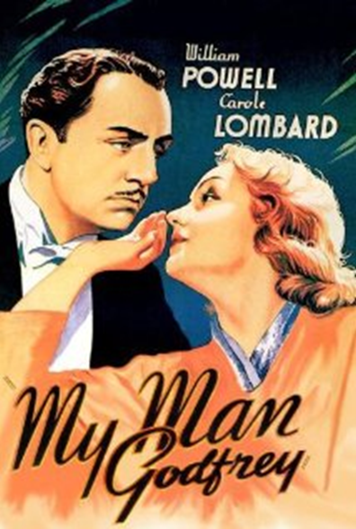

William Powell as Godfrey
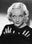 Carole Lombard as Irene Bullock Alice Brady as Angelica Bullock
Gail Patrick as Cornelia Bullock
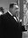 Eugene Pallette as Alexander Bullock
Jean Dixon as Molly
Allan Mowbray as Tommy Gray
Mischa Auer as Carlo
Pat Flaherty as Mike Flaherty
Robert Light as Faithful George

Other Selected TV & Movie Versions and Features:

1101 Park Avenue
(1935) Short Story on which the movie was based

My Man Godfrey
(1938, 1946) Radio Drama

Daffy Dilly
(1948) Short

School for Tramps
(1955) Movie

My Man Godfrey (aka Her Man Godfrey)
(1957) Movie

You Bet Your Life, Episode #8.19
(1958) Trivia Answer

My Man Godfrey
(1985) Stage Musical, uncompleted

Dogs in Space
(1986) Movie, playing in background

Six Feet Under
(2004) TV, characters watch the movie

Gilmore Girls: Say Something
(2005) TV, movie is showing in a theater
Trivia:

Carole Lombard had a habit of ad-libbing by inserting swear words into the dialogue, which necessitated the re-shooting of several scenes.

Although stars William Powell and Carole Lombard had been divorced for three years by the time they made this, when offered the part Powell declared that the only actress right for the part of Irene was Lombard.

A stand-in (Chick Collins) was used when William Powell carries Carole Lombard over his shoulder up the stairs to her bedroom.

Jane Wyman has an uncredited role. She can be seen standing at the back of the crowd in the Waldorf Ritz Hotel as Godfrey makes his speech condemning them all as "nitwits".

The Character of Irene Bullock is in her late teens; however, Carole Lombard was 27/28 at the time of production.

Eddie Kane is in studio records as a cast member, but he was not seen in the movie.

Synopsis:

When New York socialites Cornelia and Irene Bullock both go to the city dump to obtain a "forgotten man" for a scavenger hunt being conducted at the Waldorf-Ritz Hotel, they encounter down-and-out Godfrey Parke. He is charmed by Irene and agrees to be turned in as a "find." Irene wins the contest, but Godfrey is disgusted by the careless attitude of the wealthy crowd and deems it a pleasure to return to the dump. Smitten by Godfrey, however, Irene hires him as the family butler. Their scatterbrained mother Angelica supports a resident protégé named Carlos. When Irene falls in love with Godfrey and kisses him, he admonishes her, and she sulks.
During a tea party thrown by Irene, one of the guests, Tommy Gray, recognizes Godfrey as an old college chum. In order to keep his past a secret, Tommy claims Godfrey is married with five children. Irene is horrified and, out of spite, suddenly announces her engagement to Charlie Van Rumple. Tommy and Godfrey meet privately for lunch, and Godfrey's background is revealed to be old Bostonian wealth. He tells Tommy he became a derelict by his own choosing. Later Cornelia tries to set Godfrey up by planting her pearls under his bed and calling the police, but a search reveals nothing, and Alexander, suspicious of his daughter's motives, encourages the police to drop the matter.
When Irene's engagement is broken, she and Cornelia go on a lengthy trip to Europe. Godfrey, meanwhile, re-visits the dump with Tommy, where he hits on a scheme to turn the forgotten men into working men. When Irene returns from Europe, she still longs for Godfrey and assumes a melodramatic depression.
After a beleaguered Alexander announces he is broke, Godfrey surprises everyone by resigning and revealing that he had taken the pearls from his bed and used them as collateral for stocks he played on the market in Alexander's name, thereby saving the family fortune. He returns the pearls to Cornelia, who apologizes for treating him shabbily.
Having learned something from each member of the family, Godfrey bids them farewell and returns to the city dump, which he has transformed into a nightclub that employs his fellow derelicts. Irene follows him and determinedly sets up housekeeping. Tommy, who is aware of Irene's intentions, sends the mayor into Godfrey's office in the nightclub, and much to the surprise of a dumbfounded Godfrey, he and Irene are married.

Movie History:

My Man Godfrey was in production during the most volatile period in Universal's long history. The studio was reeling from the recent costly flop, Sutter's Gold (1936) and was banking heavily on the success of Show Boat (1936). With the relatively economical cost of Godfrey (under $700,000) the new owners were able to capitalize on both it and Show Boat's revenues to finance a much cheaper and scaled back 1937 production roster. The "new" Universal wouldn't produce another true A-list film until 1939 with Son of Frankenstein (1939) and Destry Rides Again (1939). Abbott and Costello truly revitalized the studio beginning in 1941.

My Man Godfrey (1936) is one of the 1930's most delightful, classic screwball comedies. It was directed by Gregory La Cava for Universal and is now considered the definitive screwball comedy, with its social commentary on life during the 30s. The film, filled with marvelous character actors resonated with Depression era audiences for its statements on morality and class.

In the same year, another William Powell film - The Great Ziegfeld - won the Best Picture and Best Actress awards, and Powell also appeared in Libeled Lady (1936) and After the Thin Man (1936).

Movie Awards:

This is the only movie to ever get Oscar nominations for writing, directing and all four acting awards without being nominated for Best Picture. It was also the only movie to ever get those six nominations without winning in any of the categories all until American Hustle (2013).

Premiere voted this movie as one of "The 50 Greatest Comedies Of All Time" in 2006.

Was selected for preservation by the national film registry in 1999, being referred to as culturally significant by the United States Library of Congress.

Sources:
http://www.filmsite.org/myman.html
http://www.tcm.com/tcmdb/title/5794/My-Man-Godfrey/
http://www.imdb.com/title/tt0028010/

