Books kept by a library have a “shelf life” and even book manufacturers these days do not make books to last. However, books can be repaired so that they remain readable for longer with just a little knowledge, skills, and practice.
Types of Book Damage:
- Torn dust cover – repair as paper or discard.
- Chewed cover corner – can be sanded down, or covered with tape.
- Broken Spine (inside or outside) – can be covered with cloth tape, mended inside with cloth hinge tape, or signatures re-glued to the spine.
- Torn cover joint – can be repaired with cloth hinge tape and/or the outside covered with cloth tape.
- Torn endpapers – can repair as a regular tear.
- Torn pages – can be repaired with glue or tape.
- Pages falling out – the repair is known as a “tip-in” because once the edge is covered with glue the page is tipped back into place.
- Mold – can be slowed/stopped by sealing in a bag in the freezer for several months. Very hard to stop entirely.
- Stains – can be sanded out if on the fore edge or head papers. Cover may be cleaned with book cleaner.
- Water damage – Dry books open and standing up. Some wrinkles can be flattened out in a book press.
- Smoke and other smells – Store in a sealed container with charcoal in a mesh bag.
Repair Tools & Supplies
These supplies can be found in a well-stocked office, from www.demco.com or www.shopbrodart.com. This is not an exhaustive glossary – other tools and supplies can be used for more short-term repairs, and you can use tapes in place of adhesives many times.
Absorbene Dirt Eraser – a rubber like eraser that is very gentle and can erase stains from inside pages.
Archival Storage Boxes – acid-buffered cardboard boxes that will prevent future yellowing of older documents. Can also use acid-buffered tissue paper.
Bone Folder – an 8” long flat plastic stick used to smooth adhesive laminate and tapes.
Book Cleaner – a non-water cleaning paste for book covers. Wipes clean.
Book Cloth Tape – a long strip of adhesive cloth tape used to replace a spine.
Book Press – a large clamp with Masonite dividers; can be used to evenly apply several pounds of force to several books at once.
Book Tape – looks like heavy duty packing tape, but is Ph balanced and will not yellow with age. Scotch 845 tape is the only commercial brand approved for use on books.
Cloth Hinge Tape – tape that has a sewn middle seam to form an “X” shape. Often comes with pre-applied dry adhesive. Used to reattach a cover panel to the spine or spine cover.
Corner Covers – adhesive plastic or fabric that is pre-cut to wrap around the corner of a book’s cover
Document Cleaning Pad – a cloth bag filled with non-abrasive grit free cleaning powder for the most sensitive books.
Filament Tape – reinforced tape used to secure book jacket covers.
Filmoplast P Tape – very thin ph-balanced adhesive tape used for partial tears or cuts on pages.
Good Quality Scissors – get heavy duty paper cutting scissors in a variety of sizes
Goo-Gone – a highly concentrated degreaser. Used to remove stubborn adhesive left by stickers on book covers.
H-Bands – Giant rubber bands in the shape of an “H” that will evenly and completely wrap around a book to secure it closed.
Jacket Covers – creates a clear sleeve over a book’s dust jacket
Label Peeler – looks like a square offset spatula with a sharp edge, used to get under and lift labels off books.
Laminate – Used on paperback books to add a plastic cover
Long Reach Stapler – Usually with a 12” reach, can be used to repair children’s books with a stapled binding.
Newspaper Rolls – Used to keep the shape of the fore edge while a spine is being repaired. Use several pages and roll very tightly to create a firm tube. Secure with tape.
Norbond Liquid Plastic Adhesive – a ph-balanced liquid plastic (polyvinyl acetate) that dries clear and flexible and won’t yellow or turn brittle. Can be used like white glue.
Paste Brush – used to aid in applying liquid adhesive. Can use unwanted paint brushes too.
Sandpaper – various grits can be used to sand off a layer of the fore edge or head edge to remove stains, ink, spots, etc.
Spine Covers – adhesive plastic or fabric that is pre-cut to wrap around the top or bottom of a book’s spine.
Vinyl & Plastic Erasers – can help remove stubborn pencil, pen, and ink stains.
Wax Paper – used to protect books from unwanted glue traveling outside the repair area.
Wooden Dowels – used to apply glue to small spaces.
X-acto or Craft Knife – clean tears with precision.
NEVER USE: glue sticks, packing tape, rubber cement, shelf paper, wrapping paper, brown paper
Know Your Book Vocabulary!

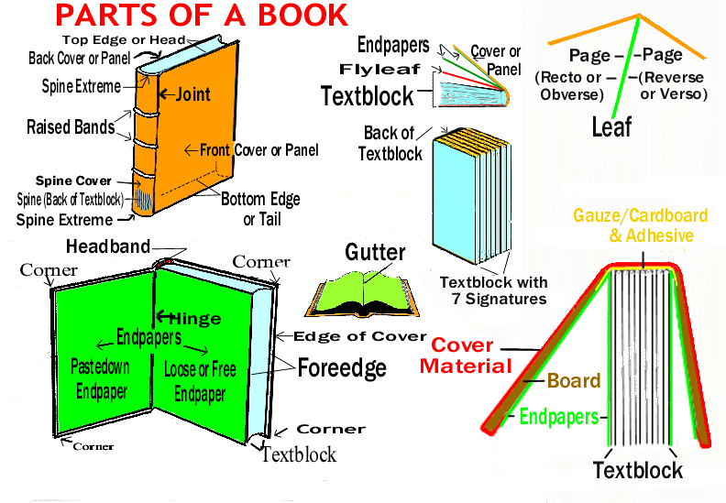
More how-to repair videos and resources can be found online:
SULPreservation – Syracuse University Library’s book preservation channel on YouTube.
Save Your Books – a book repair expert demonstrates techniques you can use on You Tube.
Find a conservator for antiques and costly items at the American Institute for Conservation of Historic and Artistic Works: http://www.conservation-us.org/membership/find-a-conservator.
Dartmouth College has created an online manual on book repair: http://www.dartmouth.edu/~library/preservation/repair/index.html

